
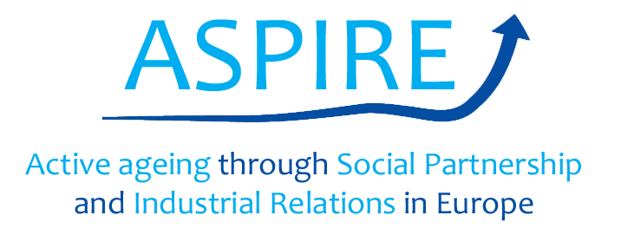

Evaluation of the pilot training module

Once that our piloting session is over, please tick off (✔) the option that you think is more in line with your point of view about the ASPIRE pilot training module.
To what extent do you think that the training materials… | A lot | Some | Little | None
Are relevant to your role as social partner?
May be effective to help you facilitate constructive dialogue on active ageing in industrial relations’ contexts?
May support you in the promotion of active ageing in collective agreements?
May make you able to suggest an active ageing intervention at your workplace?
May make you able to implement an active ageing intervention at your workplace?
Now that you are familiar with the training materials, in which areas there is a need for improvement? | A lot | Some | Little | None
UNIT 1: Why this training? Explaining the purpose of the training
UNIT 1: Who is the training for? Specify the audience
UNIT 2: What is active ageing at work about? Understanding the concept
UNIT 2: How active ageing is related to social dialogue, i.e. dialogue between social partners?
UNIT 3: Which are barriers for active ageing at the workplace?
UNIT 3: Which are facilitators for active ageing at the workplace?
UNIT 4: Examples of good practice of active ageing at the workplace
UNIT 5: How to measure progress?
UNIT 6: Pool of resources
UNIT 8: Community of practice on active ageing
Please, share with us below the most critical improvements that you feel should be made to the training materials:
Thank you for your cooperation!

