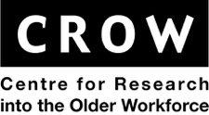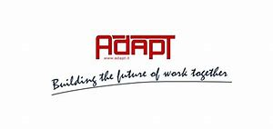

ASPIRE - Active Ageing through Social Partnership and Industrial Relations in Europe

WHY?
- Aging of societies
- Shrinking and aging the potential labour forces
- Extending life expectancy
- Few generations on labour market
- People 50+ have knowledge and experience
- Employers need tools to extend the economic activity of people aged 50+
- Social partners plays very important role on the labour market

HOW?
The aim of the project is to understand processes through which social partners develop, pilot and implement active ageing interventions, including collective agreements, and reorient away from a collusion toward early retirement. European social partners have developed programmes to support older workers delay retirement and ASPIRE's aim is to understand how Industrial Relations (IR) systems can facilitate and/or inhibit such agreements.
RESEARCH QUESTIONS:
- How do different industrial relations (IR) structures facilitate and/or inhibit the dissemination and implementation of collective agreements on active ageing?
- How are age and employment perceived in workplace contexts within different IR systems?
- How do employers and trade unions respond to EU and national social activation policies in creating sustainable work opportunities for older workers?
- How are the interests of older and younger workers negotiated and reconciled through workplace level mechanisms?
- How are good practice and innovations in the dissemination of active ageing approaches shared between and within different national contexts and in Europe?

REPORTS:
http://adapt.it/aspire/publications.html

PROJECT WEBSITE:
http://www.adapt.it/aspire/

