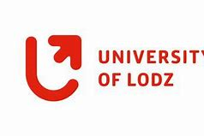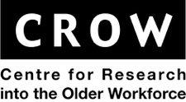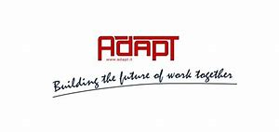

Conference Active Ageing through Social Partnership and Industrial Relations in Europe,
April 9th , Brussels

The aim of the conference is discussion about development and implementation active ageing interventions, including collective agreements and age management processes in which the social partners are involved

What we can observe?
- Aging of societies
- Shrinking and aging the potential labour forces
- Extending life expectancy
- Few generations on labour market
- People 50+ have knowledge and experience
- Employers need tools to extend the economic activity of people aged 50+
- Social partners plays very important role on the labour market
- The need to reorient the early retirement system

12:00 | Arrival and registration  Welcome Coffee break (and lunch??
12:45 – 13:45 | Welcome address & Keynote Session
13:45-14:15 | ASPIRE - Active Ageing through Social Partnership and Industrial Relations in Europe - Project results presentation
14:15-15:00 | Policy Roundtable
15:00-15:30 | Coffee break and poster session
15:30-15:00 | Aspire Training tool presentation
15:00 | Discussion and closing ceremony

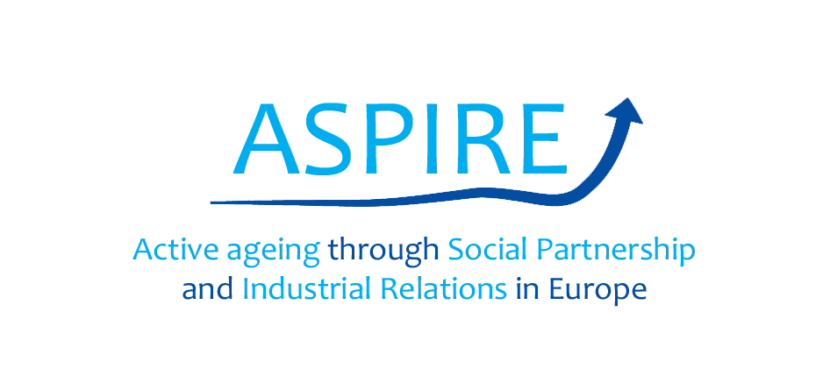

Venue:

REPORTS:
http://adapt.it/aspire/publications.html

PROJECT WEBSITE:
http://www.adapt.it/aspire/

