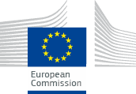 | 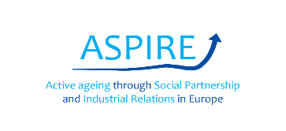
Introduction
Welcome to the project completion workshop for the ASPIRE project. In 2017, European level social partners Business Europe, UEAPME, CEEP, ETUC, Eurocadres, CEC agreed a framework for promoting and disseminating strategies for workplace active ageing and intergenerational solidarity in workplaces across Europe. Through twenty-six workshops in four countries, we spoke with employers, unions and other stakeholders on engaging in a social dialogue on workplace ageing and supporting older and younger workers in their careers. The objectives of the project were to discover how social partners in the four countries:
  - develop, pilot and embed human resource management (HRM) interventions which support older workers
  - reconcile competing intergenerational interests
  - shift from an early retirement toward active ageing orientation
This workshop is meant to discuss the findings. Following the briefings, we will launch an online tool for workplace level social partners to help them start a dialogue on active ageing and intergenerational solidarity.
Timetable
Time | Topic | Speaker
9:30-10:00 | Coffee and registration
10:00- 10:30 | Welcome and setting the scene
10:30 to 11:00 | About ASPIRE: Main findings | Matt Flynn, project coordinator
11:00 to 11:30 | UK Case study | Chris Ball, research fellow
11:30 to 11:45 | Social partner’s response
11:45 to 12:15 | Lunch
12:15 to 12:45 | Italian Case study | Paolo Tomessetti, Italy Co-investigator
12:45 to 13:00 | Social partner’s response
13:00 to 13:30 | Polish Case study | Iza Warwas, Poland Co-investigator
13:30 to 13:45 | Social partner’s response
13:45 to 14:15 | Spanish Case study | Mariano Sanchez, Spain Co-investigator
14:15 to 14:30 | Social partner’s response
14:30 to 15:00 | Launch of online tool | Mariano Sanchez  Matt Flynn

This project is sponsored by the European Commission Directorate for Employment, Social Affairs and Inclusion. The project team would like to offer our thanks for the funding. We would also like to thank our social partners for their support in organising and running the workshops. Our project partners include the Trades Union Congress and Employers’ Network on Equality and Inclusion (UK); CISL FP and FederDistribuzione (Italy), UGT and Macrosad (Spain) and Solidarnosc and Business Centre Club (Poland).

