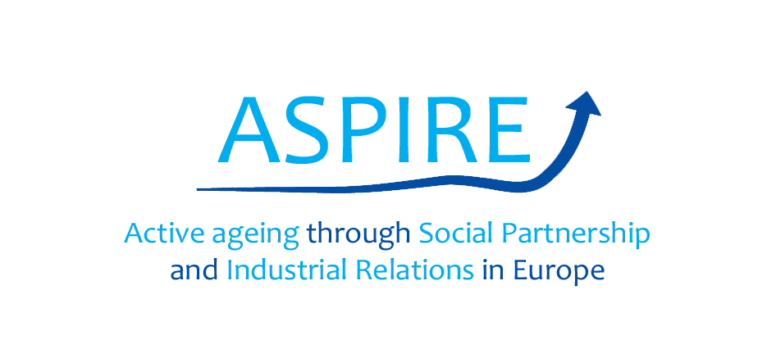

**Evaluation of final online training module**

Once that you’ve learnt about the content of the ASPIRE’s online training module, please read the statements below and tick off (✔) the option that you think is more in line with your point of view.

|  |  |  |  |  |
| --- | --- | --- | --- | --- |
| ***To what extent do you think that the training module…*** | ***A lot*** | ***Some*** | ***Little*** | ***None*** |
| May be **relevant** to your role as social partner? |  |  |  |  |
| May **support** you in the promotion of active ageing in collective agreements? |  |  |  |  |
| May make you able to **suggest** an active ageing **intervention** at your workplace? |  |  |  |  |
| May make you able to **implement** an active ageing **intervention** at your workplace? |  |  |  |  |
| ***Overall, HOW EFFECTIVE do you think that the training module may be with regard to…*** | ***A lot*** | ***Some*** | ***Little*** | ***None*** |
| Start a constructive dialogue on infusing an active ageing component into industrial relations |  |  |  |  |
| Make it easier for older workers to actively participate and stay in the labour market |  |  |  |  |
| Foster appreciation of age inclusive employee management |  |  |  |  |
| Find resources to support the promotion of active ageing strategies |  |  |  |  |
| Respond to EU and national social activation policies in creating sustainable work opportunities for older workers |  |  |  |  |
| Negotiate and reconcile interests of older and younger workers |  |  |  |  |
| Get to know and share good practices and innovations in the implementation and dissemination of active ageing approaches |  |  |  |  |
| **Please, share with us below any other feedback that you may have on the training module** | | | | |
|  | | | | |

|  |  |
| --- | --- |
| Please, choose one option below: | |
| I am an employer |  |
| I am a union rep |  |
| I am (other): | |

Thank you for your cooperation!