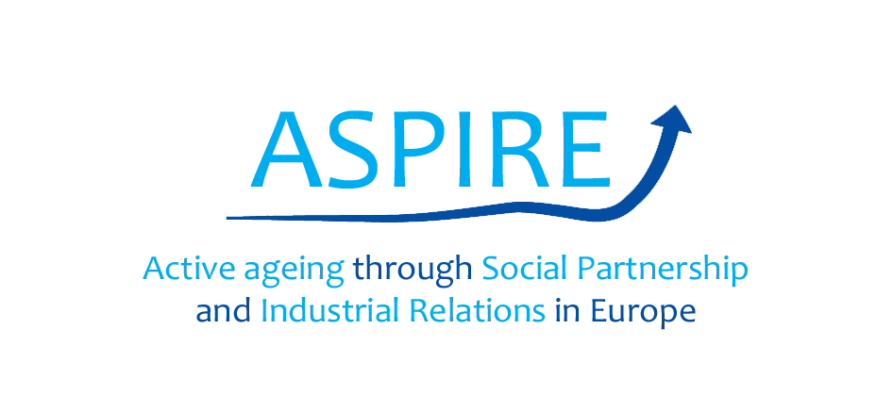

**Evaluation of the pilot training module**

Once that our piloting session is over, please tick off (✔) the option that you think is more in line with your point of view about the ASPIRE pilot training module.

|  |  |  |  |  |
| --- | --- | --- | --- | --- |
| ***To what extent do you think that the training materials…*** | ***A lot*** | ***Some*** | ***Little*** | ***None*(please explain)*** |
| Are relevant to your role as social partner? |  |  |  | X |
| May be effective to help you facilitate constructive dialogue on active ageing in industrial relations’ contexts? |  | X |  |  |
| May support you in the promotion of active ageing in collective agreements? |  |  | X |  |
| May make you able to suggest an active ageing intervention at your workplace? |  | X |  |  |
| May make you able to implement Age Management interventions at your workplace? |  | X |  |  |
| ***Now that you are familiar with the training materials, in which areas there is a need for improvement?*** | ***A lot*** | ***Some*** | ***Little*** | ***None*(please explain)*** |
| UNIT 1: Why this training? Explaining the purpose of the training |  |  | X |  |
| UNIT 1: Who is the training for? Specify the audience |  |  | X |  |
| UNIT 2: What is active ageing at work about? Understanding the concept |  |  | X |  |
| UNIT 2: How active ageing is related to social dialogue, i.e. dialogue between social partners? |  |  | X |  |
| UNIT 3: Which are barriers for active ageing at the workplace? |  |  | X |  |
| UNIT 3: Which are facilitators for active ageing at the workplace? |  |  | X |  |
| UNIT 4: Examples of good practice of active ageing at the workplace |  |  | X |  |
| UNIT 5: How to measure progress? |  |  | X |  |
| UNIT 6: Pool of resources |  |  | X |  |
| UNIT 8: Community of practice on active ageing |  |  | X |  |
| **Please, share with us below the most critical improvements that you feel should be made to the training materials:** | | | | |
| **First of all, we should consider that companies are not social partners and we are not obliged to engage with trade unions to deal with problems we face at the workplace. Some times it seems that the training module confuses social partners with other actors of HRM and firm-level industrial relations. Once we have clarified this, we could say that the training module is well balanced in terms of the interests that companies and workers have towards ageing issues. Overall we agree with the contents of the training module and especially we believe this could help in promoting a participatory approach to manage age problems at workplace.** | | | | |

Thank you for your cooperation!