Part 3 Barriers and facilitators
Main barriers
▪Changes in the labour market (5’) [PL]

Changes in the labour market
Identified Barrier: An increasing part of labour force has reached 55 years of age
European societies are ageing at a rapid pace which is best illustrated by the increase in the number of people aged 65+ per 100 people aged 15-64 (old-age dependency rate). While in 2006, in the EU28 there were 25 people at the age of 65+ per hundred people aged 15-64, in 2017 there were almost 30, and in 2050 there will be more than 50. The progressive demographic ageing of the population is accompanied by the ageing of the labour resources at the age of 20-64. An increasing part of labour force aged 20-64 has already reached 55 years of age. On average, in the EU28 there were 17.3% of them in 2017 – an exceptionally high percentage, over 20%, can be found in Germany and Lithuania (Graph 1). These significant changes are demonstrated by a high growth rate of the share of people aged 55-64 among those working in the entire EU – in 2000, this group constituted only 10% of people aged 20-64.
Graph 1. Number of people at the age of 55-64 as a percentage of total employment of those aged 20-64 in the EU28 in 2017
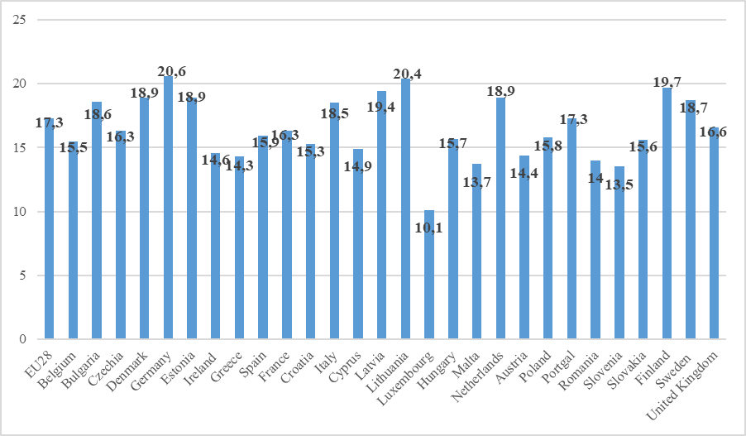
Source: Own calculation based on Eurostat lfsi_emp_a
There are versatile reasons underlying the increasing professional activity of people aged 55-64. As a result, more and more of them decide to continue their career – in 2005 in countries such as Austria and Slovakia no more than 30% of people aged 55-64 remained in employment whereas in 2017 – at least half of them. The highest percentage is reported in Sweden – 76.4% and Germany – 70.1% (Graph 2). The lowest professional activity of older employees can be noted in Greece (38.3%) and Luxembourg (39.8%).
Graph 2. Number of people remaining in employment at the age of 55-64 as a percentage of total population at the age of 55-64 (employment rate of older workers) in 2005 and 2017 in the EU country members (only countries where employment rate exceeded 50% in 2017).

Source: Eurostat: tesem050
The consequence of the ageing labour resources in EU countries is the employers’ awareness that not only it will be increasingly difficult for them to find middle-aged and younger employees, but also they will have to deal with workers who are at least 50 years old. They are a valuable human capital for the company, they know its corporate culture.
The situation of 55+ people in the labour market seems quite good since the unemployment rate in 2017 was on average lower among the elderly than the younger in the EU28 – 5.9% among people aged 55-59 and 5.6% among those who are 60-64 whereas 16.8% and 10.0% among the young people aged 15-24 and 25-29 respectively. However, a job loss after the age of 55 is associated with great difficulties related to finding a new employment. As a result, the group of older people includes a significant percentage of long-term unemployed and so-called discouraged workers, i.e. those who grew frustrated by the long-term fruitless search for employment and thus withdrew from the labour market and chose inactivity instead. If they succeed in finding a job again, they get on average 25% less than before (calculations for the US labour market in 2018). It is estimated that in the US 15% of college-educated older workers are doing low-paying jobs.
A possible solution: Better information, analysis of the ageing employees’ impact on the employment by occupation and specialities – a long-term approach
According to the Directive of the Council of the European Union 2000/78/EC on equal treatment in employment and occupation as well as the implementation of one of the Autonomous framework agreement on active ageing and an inter-generational approach goals – Increasing the awareness and understanding of employers, workers and their representatives of the challenges and opportunities deriving from demographic change, it is the trade unions’ interest to make an effort to maintain ageing employees in employment.
Therefore, trade unions should draw attention to the situation of 55+ people in the organisation, participate in the talks with the management about possible shifts of older employees to other jobs within the organisation and strive to minimize the possibility of older employees’ dismissal. In addition, they should rise the older workers’ awareness of both their rights and risks they are exposed to in the labour market due to their age.
Questions to consider
- Is the structure of employees known (including women and men by age and posts occupied in the company)?
- Are there any employment projections by age that include the demand for employees in various occupations and specialities?
- Are there any steps taken to protect the company against the possibility of the shortages of employees (vacancies) due to retirement (succession of generations)?
- What methods are used in the company to protect it against the possibility of labour demand and supply imbalance caused by age?
- Is it possible to ensure the substitutability of generations at work posts in different periods of time?
- What are the possibilities of satisfying employment needs threatened by the employees’ progressive ageing in the workplace?

